Basic Usage of Slices

Let’s create a basic list:

- >>> nums = [10, 20, 30, 40, 50, 60, 70, 80, 90]

2.

What if we want to take a sublist from the nums list? This is a snap when using slice:

- >>> nums = [10, 20, 30, 40, 50, 60, 70, 80, 90]

- >>> some_nums = nums[2:7]

- >>> some_nums

- [30, 40, 50, 60, 70]

5.

So, here is our first example of a slice: 2:7. The full slice syntax is: start:stop:step. start refers to the index of the element which is used as a start of our slice. stop refers to the index of the element we should stop just before to finish our slice. step allows you to take each nth-element within a start:stop range.

In our example start equals 2, so our slice starts from value 30. stop is 7, so the last element of the slice is 70 with index 6. In the end, slice creates a new list(we named it some_nums) with selected elements.
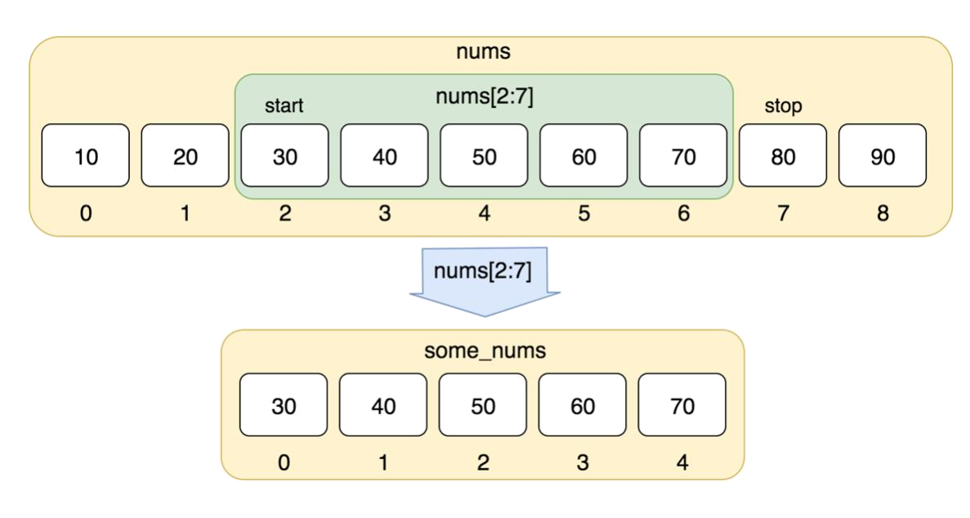

We did not use step in our slice, so we didn’t skip any element and obtained all values within the range.

With slices we can extract an arbitrary part of a list, e.g.:

- >>> nums = [10, 20, 30, 40, 50, 60, 70, 80, 90]

- >>> nums[0:4]

- [10, 20, 30, 40]

Here we start from the first element(index 0) and take a list till the element with index 4.

Taking n last elements of a list

Negative indexes allow us to easily take n-last elements of a list:

- >>> nums = [10, 20, 30, 40, 50, 60, 70, 80, 90]

- >>> nums[-3:]

- [70, 80, 90]

Here, the stop parameter is skipped. That means you take from the start position, till the end of the list. We start from the third element from the end (value 70 with index -3) and take everything to the end.

Taking every nth-element of a list

What if we want to have only every 2-nd element of nums? This is where the step parameter comes into play:

- >>> nums = [10, 20, 30, 40, 50, 60, 70, 80, 90]

- >>> nums[::2]

- [10, 30, 50, 70, 90]

Here we omit start/stop parameters and use only step. By providing start we can skip some elements:

- >>> nums[1::2]

- [20, 40, 60, 80]

And if we don’t want to include some elements at the end, we can also add the stop parameter:

We can freely mix negative and positive indexes in start and stop positions:

- >>> nums = [10, 20, 30, 40, 50, 60, 70, 80, 90]

- >>> nums[1:-1]

- [20, 30, 40, 50, 60, 70, 80]

- >>> nums[-3:8]

- [70, 80]

- >>> nums[-5:-1]

- [50, 60, 70, 80]

